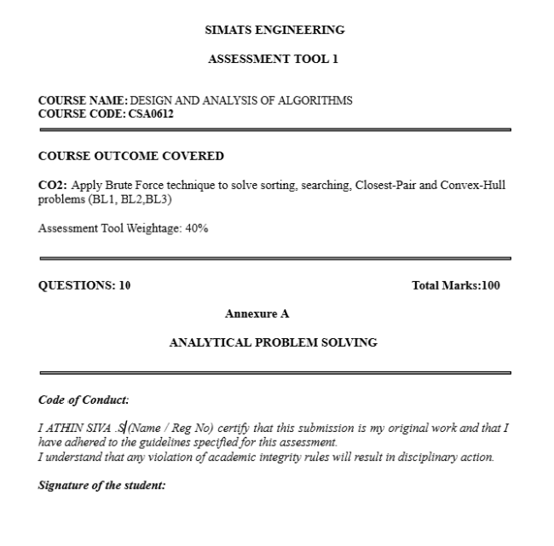
Q61. Closest Pair – Warehouse Location Analysis
Aim
To identify the two nearest warehouses using the Brute Force Closest Pair Algorithm, compute the distance between every pair of warehouses, count the total pairwise comparisons, and analyze the algorithm's efficiency.

Problem Interpretation
A logistics company has warehouses located at the following coordinates:
[
(2,1),\ (5,4),\ (6,5),\ (10,9),\ (3,2),\ (8,7)
]
The objective is to determine the two warehouses that are closest to each other. Finding the nearest warehouses helps in reducing transportation costs, improving inventory sharing, and enabling faster emergency deliveries.

Why Brute Force?
The Brute Force Closest Pair algorithm is appropriate because:
- It checks every possible pair of warehouses.
- It guarantees the correct minimum distance.
- It is easy to implement.
- It is suitable for a small number of warehouse locations.

Formula Used
The Euclidean distance between two points is
[
d=\sqrt{(x_2-x_1)^2+(y_2-y_1)^2}
]

Step 1: Label the Warehouses
Warehouse | Coordinates
W1 | (2,1)
W2 | (5,4)
W3 | (6,5)
W4 | (10,9)
W5 | (3,2)
W6 | (8,7)

Step 2: Compute Distances Between Every Pair
W1–W2
[
\sqrt{(5-2)^2+(4-1)^2}
=\sqrt{9+9}
=\sqrt{18}=4.24
]
W1–W3
[
\sqrt{(6-2)^2+(5-1)^2}
=\sqrt{16+16}
=\sqrt{32}=5.66
]
W1–W4
[
\sqrt{(10-2)^2+(9-1)^2}
=\sqrt{64+64}
=\sqrt{128}=11.31
]
W1–W5
[
\sqrt{(3-2)^2+(2-1)^2}
=\sqrt{1+1}
=\sqrt{2}=1.41
]
W1–W6
[
\sqrt{(8-2)^2+(7-1)^2}
=\sqrt{36+36}
=\sqrt{72}=8.49
]

W2–W3
[
\sqrt{(6-5)^2+(5-4)^2}
=\sqrt{1+1}
=\sqrt{2}=1.41
]
W2–W4
[
\sqrt{(10-5)^2+(9-4)^2}
=\sqrt{25+25}
=\sqrt{50}=7.07
]
W2–W5
[
\sqrt{(3-5)^2+(2-4)^2}
=\sqrt{4+4}
=\sqrt{8}=2.83
]
W2–W6
[
\sqrt{(8-5)^2+(7-4)^2}
=\sqrt{9+9}
=\sqrt{18}=4.24
]

W3–W4
[
\sqrt{(10-6)^2+(9-5)^2}
=\sqrt{16+16}
=\sqrt{32}=5.66
]
W3–W5
[
\sqrt{(3-6)^2+(2-5)^2}
=\sqrt{9+9}
=\sqrt{18}=4.24
]
W3–W6
[
\sqrt{(8-6)^2+(7-5)^2}
=\sqrt{4+4}
=\sqrt{8}=2.83
]

W4–W5
[
\sqrt{(3-10)^2+(2-9)^2}
=\sqrt{49+49}
=\sqrt{98}=9.90
]
W4–W6
[
\sqrt{(8-10)^2+(7-9)^2}
=\sqrt{4+4}
=\sqrt{8}=2.83
]

W5–W6
[
\sqrt{(8-3)^2+(7-2)^2}
=\sqrt{25+25}
=\sqrt{50}=7.07
]

Step 3: Distance Summary Table
Pair | Distance
W1–W2 | 4.24
W1–W3 | 5.66
W1–W4 | 11.31
W1–W5 | 1.41
W1–W6 | 8.49
W2–W3 | 1.41
W2–W4 | 7.07
W2–W5 | 2.83
W2–W6 | 4.24
W3–W4 | 5.66
W3–W5 | 4.24
W3–W6 | 2.83
W4–W5 | 9.90
W4–W6 | 2.83
W5–W6 | 7.07

Step 4: Closest Pair
Minimum distance:
[
\boxed{\sqrt{2}\approx1.41}
]
There are two closest pairs:
- W1 (2,1) and W5 (3,2)
- W2 (5,4) and W3 (6,5)
Both have the same minimum distance of 1.41 units.

Step 5: Number of Pairwise Comparisons
For n = 6 warehouses,
[
\frac{n(n-1)}{2}
\frac{6\times5}{2}
=15
]
Total comparisons = 15

Time Complexity Analysis
Case | Time Complexity
Best Case | O(n²)
Average Case | O(n²)
Worst Case | O(n²)
Since every pair must be examined, the running time remains O(n²) in all cases.

Correctness Verification
- All possible warehouse pairs were examined.
- Euclidean distance was calculated for each pair.
- The smallest distance (1.41) was identified correctly.
- Therefore, the algorithm correctly finds the nearest warehouses.

Logistics Optimization
The closest warehouse pairs can be used to:
- Reduce transportation time between warehouses.
- Enable quick transfer of inventory.
- Improve emergency stock availability.
- Lower fuel and operational costs.
- Enhance overall supply chain efficiency.

Result
Using the Brute Force Closest Pair Algorithm, all 15 warehouse pairs were compared. The minimum distance found was 1.41 units, occurring between W1–W5 and W2–W3. The algorithm correctly identifies the nearest warehouses with a time complexity of O(n²), making it suitable for small datasets and useful for logistics planning and warehouse optimization.

RUBRICS FOR CALCULATION

Analytical Problem Solving
Criteria | Weightage | Level 4 (Exemplary) | Level 3 (Proficient) | Level 2 (Developing) | Level 1 (Beginning)
Problem Understanding | 20% | Clearly interprets problem, identifies all parameters and requirements accurately | Understands problem with minor gaps | Partial understanding; misses key elements | Misinterprets or unable to understand problem
Method Selection | 20% | Selects most appropriate method/formula with strong justification | Selects correct method with minor errors | Inappropriate or partially correct method | Unable to select method
Solution Process | 25% | Logical, systematic steps with correct approach throughout | Mostly correct steps with minor mistakes | Disorganized steps; multiple errors | No clear process
Accuracy of Calculation | 20% | All calculations accurate; correct final answer | Minor calculation errors | Frequent errors; incorrect final answer | No valid calculations
Interpretation of Results | 15% | Clearly interprets results with units and engineering relevance | Basic interpretation with minor omissions | Limited or unclear interpretation | No interpretation

